Nanaimo’s Building Community Capacity Model

The overall aim of Nanaimo Seniors Connect impact plan was to build community capacity to address seniors’ social isolation and to promote seniors’ inclusion. The work in this project was informed by a number of theories and conceptual frameworks but broadly fit within current community development and health promotion approaches. An ecological perspective was taken to understand and influence various aspects of the situation, placing primacy on context for the individual, the group and/or the broader city. The model below captures the key elements:

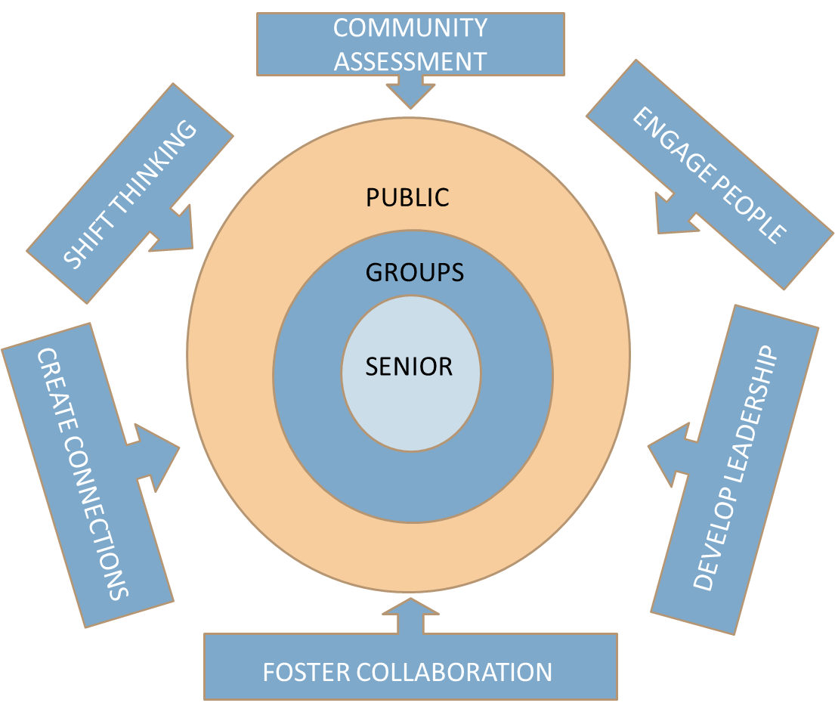

To illustrate how the model was applied in Nanaimo three examples are provided one for each level of intervention. The first example is a senior who newly located to Nanaimo and was malnourished and struggling financially. Connections to housing services, food services and help with furnishing his new home was followed by his interest in volunteering in our project in activities such as the Seniors Health Expo, outreach to a neighbourhood and increasing leadership by becoming an active member of the Participant Project Council.

The neighbourhood work is an example of identifying and segmenting a group within the community for interventions based on their needs and interests. A variety of approaches were used to assess the community including: focus groups, individual interviews, and reviewing research. Engaging pre-existing leaders and empowering new leaders promoted information dissemination from senior to senior, exploration of barriers to community activation, and grass roots participant council use of data for advocacy. Collaboration between community members, the Regional District, local businesses, non-profits and health care was fostered. Connections included intergenerational citizens through community events that increased communication about services and engaged other community stakeholders. The awareness of community barriers has begun to shift regional and provincial thinking to view transportation as a contributor to social isolation as a determinant of health.
Addressing the public at large was undertaken in a variety of ways: public events like the living history series which recognized and valued seniors experience and shifted thinking about older adults. Taking action was fostered in the champion training which empowered citizens to recognize and act on the behalf of seniors who needed assistance. The website and broadly circulated newsletters communicated information and events of interest to seniors along with the Wise folks television and CHLY radio programming which was created by seniors for seniors about seniors and connections to community issues and services.
Please contact: pennymaccourt@shaw.ca

