We want YOUR help – Use your creativity to give seniors a voice and re-frame aging more positively.
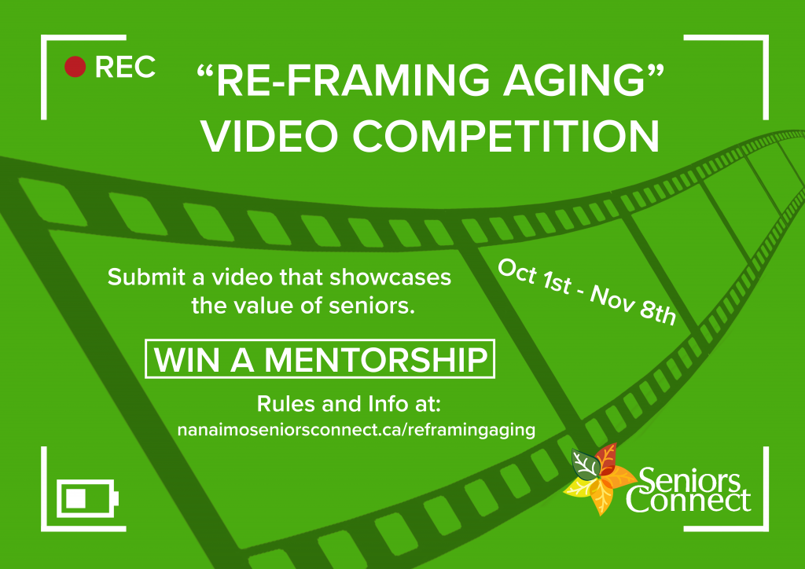

Register Here
Our purpose for hosting the “re-framing aging” 2017 Video Competition is to challenge participants and filmmakers in the Nanaimo community to creatively re-frame aging in a positive light. In spite of ageist portrayals, seniors are resilient, have a wealth of experience, and through their contributions are often the glue that holds a community together. The goal of this competition is to inspire Nanaimo to become a more age-friendly, inclusive city.
We are looking for films that showcase the value of seniors and inspire inter-generational connections and understanding.
Re-frame aging by creating a documentary, narrative, or animation that:
- Gives seniors a voice.
- Deconstructs myths of aging.
- Focuses on seniors strengths and contributions.

Prizes
First Place: A one-on-one mentor-ship with highly respected filmmaker Paul Manly. This mentor-ship will consist of three, 2 hour long, mentor-ship sessions with a focus on learning about documentary and educational film-making. The sessions will be adapted to suit the learning needs of the winner. Check out http://www.manlymedia.com/ for more information on Paul’s previous work.
Second Place: A 3-month subscription to SquareOne, a creative work space in downtown Nanaimo. Value of $1050.
Third Place: A $150 gift certificate to local electronic retail store (TBD)

Video Submission Instructions
Deadline: November 8th, 2017 at 12:00pm
- Send us a link (via email – bettertogethernanaimo@gmail.com) to with your original 2-5 minute video file. www.wetransfer.com is a great platform to help you do so. Please do not attach the video file in an email.
- We recommend that you upload the highest possible resolution of your video for maximum viewing quality.
- It is the responsibility of the participants to ensure their complete submission arrives on time and upload is finished on time. (check rules in the welcome package for more details)

Screening Date and Time
Location: VIU Malaspina Theatre (Free Parking on Sundays)
Afternoon Show: November 26th, 2017 at 12:00pm
Evening and Awards: November 26th, 2017 at 5:00pm

