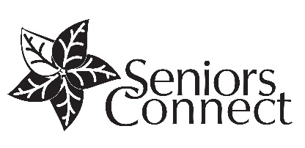
FREE SESSION: LEARN HOW TO RIDE THE BUS!

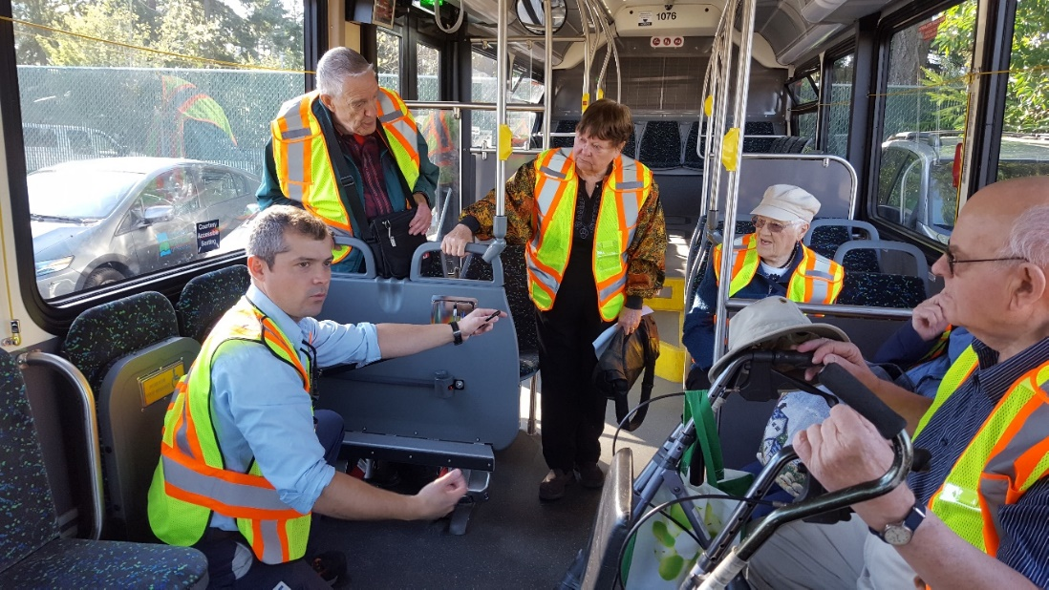
Are you feeling confused, or unsure about how to get around on transit? Then this session is for you! In partnership with the Regional District of Nanaimo, please join us for a fun and FREE group session. Learn everything you need to know to feel confident riding the bus - how to read the transit maps and schedules, buying passes, and how it works if you have a scooter, walker, wheelchair or bike, and more.
NEXT UPCOMING SESSION:
Date: Thursday, March 28 (NEW AFTERNOON SESSION ADDED!)
Time: 12:00 – 2:00PM
Location: Royal Canadian Legion Branch 256, 1630 E. Wellington Rd.
If you can’t make this session, please call to register so we can let you know about upcoming sessions.
REGISTER NOW!
Space is limited, please RSVP by email: bettertogethernanaimo@gmail.com or call: 250-760-0301.

