SENIOR RESEARCH PARTICIPANTS NEEDED
Are you interested in taking part in a photography project?

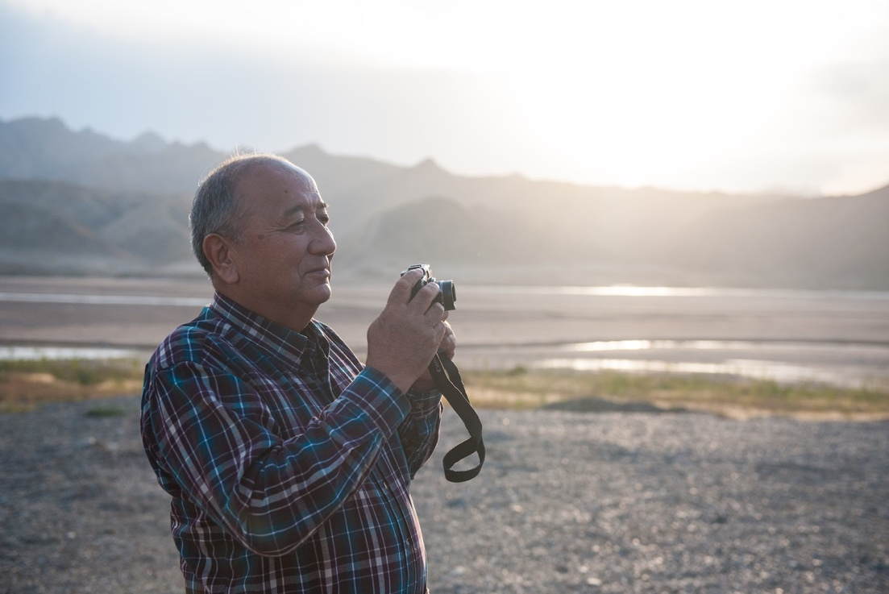

Researchers at Vancouver Island University’s Department of Media Studies are partnering with Seniors Connect and are seeking senior participants from the Seniors Connect community to take part in a collaborative research project. The project, “Visual Expressions of Connection: A Seniors’ Creative Show and Tell,” will employ Photovoice to explore issues around social isolation and integration in the elder community. We invite seniors, 55 years old and above, to let us know if you are interested.

Project Details

- Participants will take part in a 6-week long Photovoice activity, producing photographic works based on a series of questions about social isolation and integration.
- Prior to the Photovoice activity, participants will be invited to attend a basic camera skills and photography technique workshop delivered by student researchers, in addition to a workshop focussed on ethics and photography. The first session will start on Monday, August 13.
- Each week of the Photovoice activity, participants will meet to take part in photograph sharing and group reflection sessions. Participants will first be individually interviewed to discuss the meanings behind their photographs, and then join in a group photography sharing and reflection exercise with other participants.
- Participants will be reimbursed for their time and inconvenience with refreshments and food over the course of the project’s meetings and contact points.
- Seniors Connect will hold a Photography Exhibit featuring photographs from the research project in October 2018, Seniors month, to which participants are invited to help organize.

If interested, please contact Lynne Henshaw bettertogethernanaimo@gmail.com 250-760-0301, or Penny McCourt bettertogethernanaimo@gmail.com 250-756-2129.

