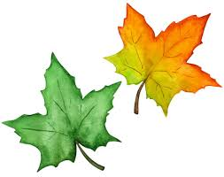
CommuniTEA Yoga – Session #2 - Are you Really Breathing?

Affirmations:
Notice how your breathing affects your everyday energy levels and relaxation. Here are a few affirmations to try, or create your own:

- I am in touch with my breathing
- I am using my breath to increase relaxation (and to decrease stress)
- I will find time each day for me to practice mindful deep breathing
The more you say, "I can!" the universe will endow you with the abilities to do just that!
Here are a few ideas to practice each day:
- Practice 3-part breathing
- If you are feeling low energy, do a few Breaths of Joy!
- Take time to notice how deep breathing makes you feel. Notice where your breath is most open and free, and where it feels tight. Breath into areas that feel tight.
- Take a walk outside in nature, be present and breath deeply
- Warm up your body first by walking or gentle movement and then try the following stretches:
  - Calf stretches at the wall or with a steady chair
  - “Thread the Needle” on the floor, bed, or seated
  - Using a belt or strap, stretch stretch hamstrings

If you have any questions, concerns or feedback, please feel free to contact me. I look forward to seeing you next week!

Namaste,
Lynne
Lynne Henshaw
lhenshaw@telus.net
Phone: 250-760-0301 (or call the Seniors Connect Centre and leave your name and number, I’ll call you back).

