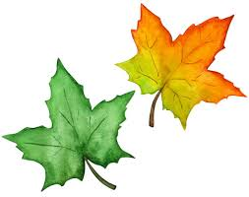
CommuniTEA Yoga – Session #4 – Hello Fall!
Letting Go & Cultivating a Daily Practice
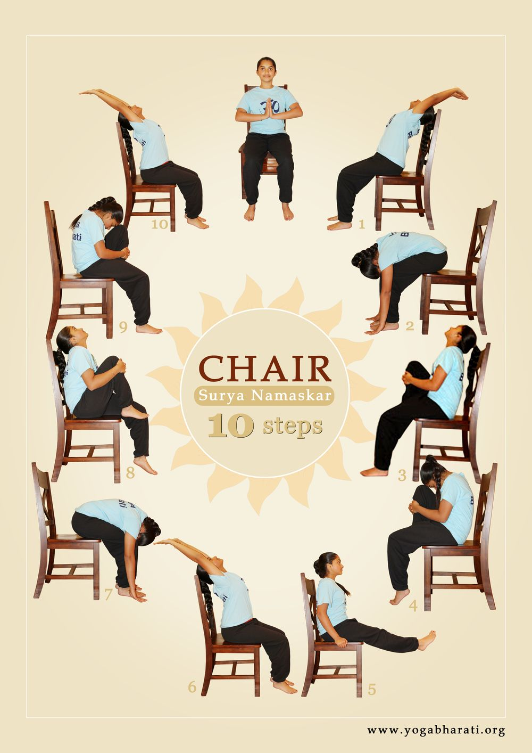
Here are a few ideas to practice each day:
- Practice 3-part or even inhale/exhale breathing
- If you are feeling low energy, do a few Breaths of Joy, or Lion pose
- Take time to notice how deep breathing makes you feel.
- Practice Gyan Mudra while breathing and meditating

If you have any questions, concerns or feedback, please feel free to contact me. I look forward to seeing you next week!

Namaste,
Lynne
Lynne Henshaw
lhenshaw@telus.net
Phone: 250-760-0301 (or call the Seniors Connect Centre and leave your name and number, I’ll call you back.

